Bryant University
SCIL263 Astronomy Lab
Practical Astronomy for the Business Major
Spring, 2014

Professor Huestis’ Solar Lab
The Sun: Our Star
Understanding its Formation and Structure
and
Observing and Analyzing Solar Phenomena

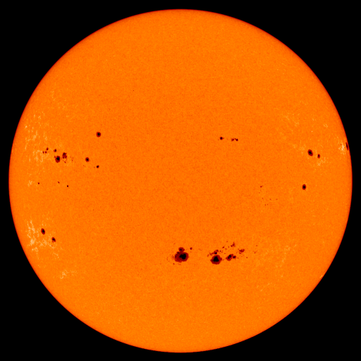

“White light” image of the Sun showing sunspots and faculae.
The orange color is due to the filter being used.

Safety issue: Should you have the opportunity to observe the Sun firsthand with an amateur telescope, make sure it is properly filtered. Also, ensure that the finder scope is capped to prevent use, and maintain supervision at all times to prevent any accidents from occurring. My mantra is: When observing the Sun, observe caution as well.

Solar Lab Introduction

This lab is designed to provide the student with a reasonable knowledge set about the origins of our Sun and how it works. Through easy to understand text, images and videos, the solar lab will also introduce the student to the basic types of solar activity that can be observed. Finally through a series of exercises, the student will apply what has been learned to further their understanding of the Sun and its affects on the Earth.

Throughout the text are web addresses* indicated in blue. When reading the text while online, all one has to do is simply CTL + click on the URL and the browser will bring up the web site. If that procedure does not work, simply “cut and paste” the URL from the text to your web browser and click run or find.

These external web sites are very important to the assignment. The information contained within them is crucial to the students’ understanding of solar fundamentals and will be included as part of the solar quiz.

Also, a component of this new and improved solar lab is a semester-long project in which teams will submit sunspot counts on a weekly basis. We will review the details on how this count is to be accomplished and administered. A percentage of your grade for this lab will be derived from your participation in the semester-long sunspot count.

*Note: a disclaimer regarding some of the videos the student will view. A few of the videos have 30-second (or less) commercials or advertisements accompanying them. Neither I nor Bryant University endorses any of the products or services presented in the videos.

The Big Bang Creates the Universe

Before we begin to learn about that life-giving star we call our Sun, we first must look back at how this whole universe came into existence. Approximately 13.7 billion years ago the Universe as we know it was born. A point in space of infinite density and temperature called a singularity suddenly “expanded.” You will note that I did not say exploded. In billionths of a second, space itself expanded and was filled with all the elementary particles required to build the universe. This event is known to astronomers and cosmologists as the Big Bang. Astronomers have been able to detect the afterglow of this cosmic event in the form of cosmic microwave background radiation, which is simply the still cooling remnant from the universe’s creation. Within about 400,000 years after the Big Bang, the first hydrogen atoms formed as the universe cooled.
http://www.youtube.com/watch?v=oLMrybV-6ys

On a large scale in the early universe, regardless of where one looked, the universe was the same (homogenous). On a smaller scale dense clusters of matter became gravitationally bound. Over time these clumps got bigger and bigger, and between 500 million years and one billion years after the Big Bang the first galaxies were born.

The Milky Way Galaxy

Our own Milky Way Galaxy formed some 13.2 billion years ago. It is currently estimated to contain some 400 billion stars. Galaxies come in a variety of shapes and sizes. While the Milky Way’s structure was originally considered to be a simple spiral (like our galactic neighbor the Andromeda galaxy in Figure #1), recent research indicates it to be a barred spiral galaxy (similar to the galaxies in Figures #2 and #3) — a flattened disk about 100,000 light years in diameter and 1,000 light years thick, with a barred core, and several spiral arms radiating out from the bar like a pinwheel. This spiral structure evolved with time, and within these spiral arms smaller dense clumps of matter eventually became “stellar systems” with stars of varying sizes, masses and temperatures. And it appears that our galaxy, like all others, has a super-massive black hole at its center.
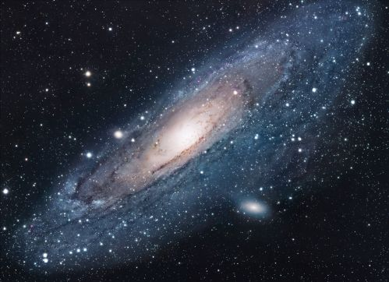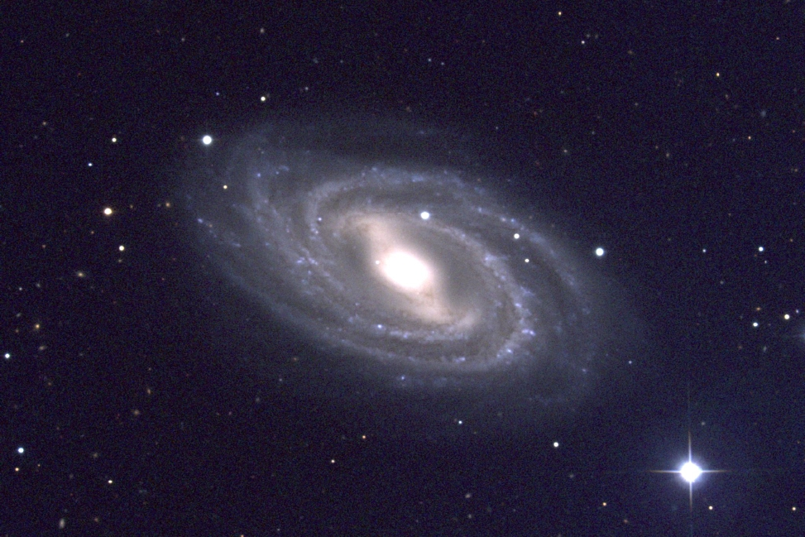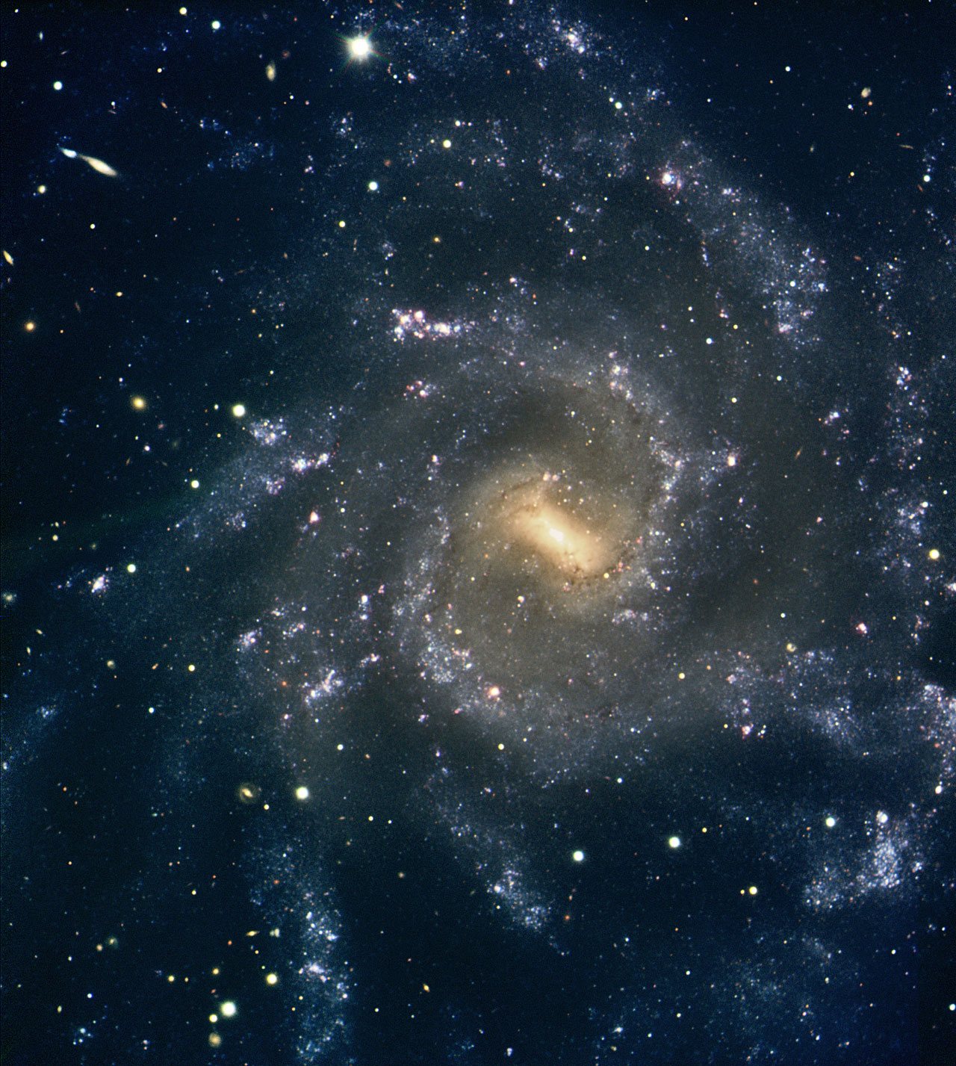
Figure #1 Figure #2 Figure #3

The Sun and our Solar System

Our stellar system was not one of the first to be born. Our solar system is too metal rich (that is, in astronomy anything heavier than helium is considered to be a metal). The only way to get the heavier elements is for them to have been formed through the fusion process in the interiors of stars and then spread throughout space during a nova or supernova explosion.

So the region of space that was to become our Sun and solar system was initially just a huge molecular gas cloud close to the inner rim of the Orion spiral arm of our galaxy. The cloud started to coalesce when one or several nearby supernova sent shockwaves through the material, causing it to heat up and condense. As the gas cloud continued to coalesce it began to rotate. Eventually the inner clump became a proto-star.

Because sufficient material existed, the proto-star continued to collapse until the temperature and pressure at its core reached a point where nuclear fusion could begin. Our Sun then began to convert hydrogen to helium. The core pressure would have initially increased, but eventually the gravitational pressure pulling inward balanced the outward pressure at the core. At that point our Sun became a main sequence star.

That was about five billion years ago. Though the Sun does exhibit a small percentage of variability, what you see today is how it looked five billion years ago, and how it will look for another five billion years. Our Sun is a G2 (a stellar spectral classification based upon a star’s surface temperature and therefore its color) yellow dwarf star about 865,000 miles in diameter. While that number may seem very large, our Sun is tiny when compared to most of the stars you can see in the night sky.

While we will examine the scale of the solar system in a separate lab this semester, I think it is important here to graphically show just how insignificant our Sun is in relationship to some of the other stars in our galaxy. It will also help illustrate just how small our home planet is in the scale of the galaxy, not to mention the whole universe. The following GIF movie starts out with the scale of the solar system in relationship to the Sun, and then compares the size of our Sun with other stars.
http://www.gifbin.com/981867

Our solar system resides about 26,000 light years from the Milky Way galactic center. In other words, our solar system is out in the boon docks! It takes our system about 250 million years to complete one orbit of the Milky Way.

If you want to contemplate a really mind-boggling fact, try to get your head around this concept: our solar system has its own motion within the Orion spiral arm of our Milky Way galaxy, and the Milky Way is also moving through space. Consequently we have never occupied the same “space” twice since our solar system’s birth.

When you look up at the night sky, most of the points of lights you see are stars and clusters which are in the local neighborhood of the Orion arm. From a dark sky, however, you can glimpse a couple of external galaxies more than two million light years away.

Sun Worshipping

Our Earth ended up in the habitable zone within our solar system. That means it was, and is, neither too hot nor too cold. And the abundance of liquid water provided the sustaining medium for the earliest of life forms. Plants evolved and thrived by photosynthesis, deriving their sustenance directly from sunlight.

Mankind’s presence on the Earth is nothing but a blink of an eye in relation to the time since the Sun and the solar system coalesced from that vast dust cloud some five billion years ago. Our earliest ancestors experienced the same Sun we see today. It brought them light and warmth, and they must have noted the seasonality of its motions through the heavens. We have no idea when this realization occurred, but this knowledge eventually allowed mankind to develop an agricultural society.
The human brain is quite adept at recognizing patterns, and in nature many patterns are cyclic. When one’s existence depended upon an understanding of the natural world, one paid close attention to details. The daily rising and setting of the Sun was very important. At one moment in the distant past someone noticed that a vertical stick (called a gnomon) placed in the ground, would cast a shadow indicating the changing altitude of the Sun as well as tracking the Sun’s apparent east to west path across the sky.
http://www.youtube.com/watch?v=ojvfx_6TFVI&feature=related
These “shadow clocks,” very simple time pieces, evolved to become the more accurate sundials by setting the angle of the gnomon to the user’s latitude. However, a sundial could only be used accurately for the latitude for which it was designed and constructed. Here’s a simple sundial animation:
http://www.edumedia-sciences.com/en/a206-sundial
In many cultures the Sun was worshipped as a god. Sun temples built to honor these gods still exist throughout the world. Unfortunately some of the rulers believed themselves to be either descendants of gods or gods themselves. But for thousands of years in our collective history the Sun was considered the ideal form of perfection. When superstition was eventually replaced with scientific thought and investigation, the mysteries of the Sun slowly evaporated as science fact took hold. Though the Sun was important for the survival of mankind, we began to understand the nature of the universe and how things worked. Challenging old and established beliefs can be risky, regardless of what definitive proof you may provide.

The general concept about the Sun and Earth’s position in the universe came down to us from Aristotle (384 – 322 B.C.). The Earth was at the center of everything. A total of 55 concentric crystalline spheres held the Sun, planets and stars which revolved around the Earth (geocentric). And most importantly, the universe, and more specifically the Sun, was perfect and unblemished.

It wasn’t until a Renaissance man by the name of Nicholas Copernicus (1473-1543) initially challenged that view sometime before 1514. After much research he postulated that the Sun was at the center (heliocentric) of the universe and everything revolved around it. His great work On the Revolutions of the Celestial Spheres was published just before his death in 1543. This revolutionary thinking is often regarded as the starting point of modern astronomy.

The Aristotelian belief in an Earth-centered universe was difficult to depose because it had been well entrenched in people’s mind set for many centuries. However, even by the time of Galileo’s first telescopic observations at the end of 1609, the Copernican system had become well established, though not fully embraced by everyone. Unfortunately the Church still held to the old beliefs.

One Dominican friar, philosopher and astronomer, Giordano Bruno (1548-1600) took Copernicus’ ideas a little too far. Though his support of the heliocentric system certainly brought him to the attention of the Church, one of Bruno’s beliefs was that the universe or nature was god, and that no physical creator god existed. This heretical idea got him burned at the stake. Given the “philosophical” climate at the time, Galileo was very cautious about the comments he made.
Since that time, mankind has learned much about how the Sun works. Many different types of scientific instruments have helped to unravel most of the solar mysteries. We’ll now begin to examine how the Sun does what it does and also study the variety of solar phenomena it displays.
You will learn the basic facts about our Sun and will take part in a semester-long project that will help you understand one of the basic examples of solar activity.

Structure of the Sun

While we can’t visually observe deep within the interior of the Sun to see what transpires there, physical laws can predict how gas behaves under extreme pressure and temperature. After observing the physical effects produced by the Sun, one can model its interior structure with great accuracy. Each of the primary solar structures detailed below surrounds the Sun in concentric circles.

First, keep in mind that the Sun behaves as a gas. Its internal rotation rate varies with depth which is called differential rotation. For instance, in the Sun’s interior, the core and radiation zone are believed to rotate almost as a solid because of their density, whereas the convection zone rotates differently with depth. This action provides a lot of turbulence near the radiation and convection zonal boundaries, which is responsible for creating the Sun’s primary magnetic field.

Please reference Figure #4 as we now examine the Sun’s interior structure in more detail.

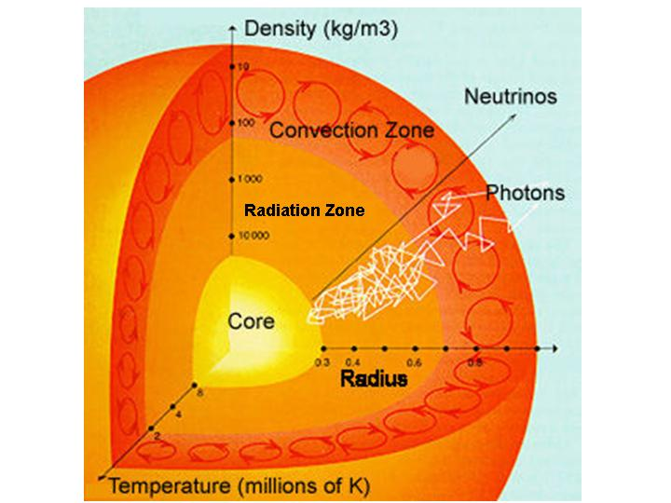
Figure #4

Core

When the Sun began to convert hydrogen to helium some five billion years ago, the pressure and temperature at its core had to be extremely high. In fact, that core had to be about 24.5 million°F for the process to begin and sustain itself. And believe it or not, the Sun converts about 515 million tons of hydrogen to helium per second. This process has been ongoing for about five billion years, and will continue to sustain this reaction for another five billion years.

The Sun is about 865,000 miles in diameter, and therefore has a radius of 432,500 miles. The core extends from the center of the Sun out to approximately one-quarter (0.25) solar radii, which computes to 108,125 miles in radius. That’s 216,250 miles in diameter – a huge volume where four hydrogen nuclei are fusing to create one helium nuclei and a gamma ray (high energy photon) in a several step reaction called the proton-proton chain. This process produces tremendous amounts of energy, including heat.

Because the core is so dense, once a gamma ray (high energy photon) is created it collides with other atoms frequently. During the collision the photon is absorbed and then a new photon is re-emitted at a lower energy level. This process happens perhaps millions of times within the core and radiation zone (next section) as a result of the creation of a single photon. Eventually a resulting photon, but not the original photon, will reach the Sun’s surface (photosphere) and escape as visible light. This photon is also the primary method by which energy is conveyed from the Sun’s core to its surface. However, to reach the surface the energy must be transferred through two additional zones, the first of which is the radiation zone.

Radiation Zone

The radiation zone is the largest region in the Sun’s interior. It stretches from the upper limit of the core 0.25 solar radii (108,125 miles) to about 0.7 solar radii (302,750 miles). That cross-section is about 194,625 miles wide. Once in this zone the energy is transferred outward by radiation. Near the core/radiation boundary the temperature is about 12,600,000°F, while at the top boundary of the radiation/convection zone the temperature has decreased to about 3,600,000°F.

Convection Zone

As the energy continues outward from the radiation zone, it next encounters the convection zone. This zone stretches from the upper limit of the radiation zone at about 0.7 solar radii (302,750 miles) to the Sun’s surface at approximately 432,050 miles from the center. That cross-section is about 129,300 miles wide. Energy/heat is transferred outward by thermal convection. It is the same process that occurs when you heat soup on a stove top. Cells of hot material called granules rise to the visible solar surface called the photosphere (more on the photosphere in the next paragraph). Here their heat is released. Now cool(er), they sink back down into the convection zone to repeat the process.

Still images and movies of the Sun show this granulation effect. Under high magnification individual granules or cells, about 600 miles across and lasting for only five to ten minutes can be seen as they rise, release their energy, and then sink below the surface. Dark lanes separate the granules. These are the areas where the cool material is subsiding below the surface. Figure #5 shows a close up of individual granules.

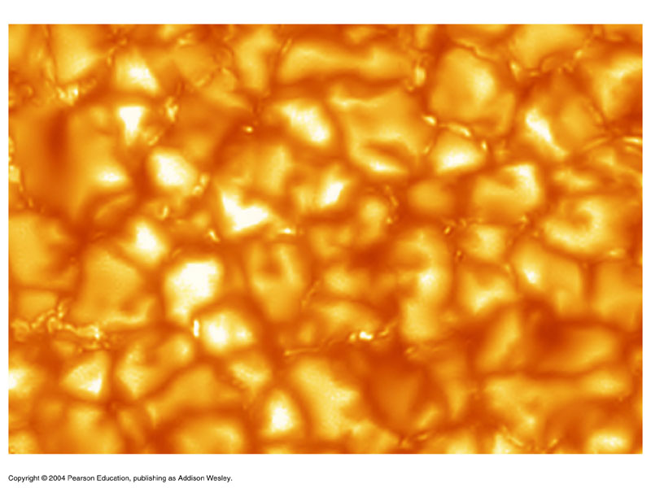
Figure #5

See a movie of solar granulation here:

http://www.suntrek.org/images/movies/SOHO5_Sunspot_close.MPG

Keep in mind that this is a time-lapse movie. In real time the granules would not be moving that fast, though over a period of a minute or two one could see changes occurring.

Figure #6 shows a cross-section of the Sun showing most of the major features we will be examining.
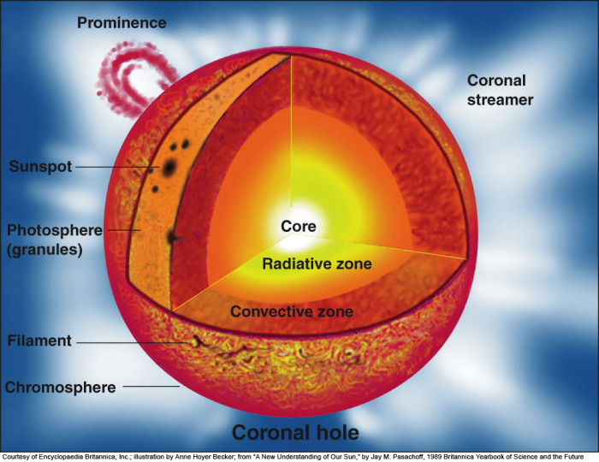
Figure #6

The Solar Surface: the Photosphere

The Sun that we see with our naked-eye or a properly filtered telescope is the photosphere. Visible light (photons) have “broken through” to this region. By the time energy has reached the photosphere the temperature has cooled to a mere 10,340°F.
The photosphere itself is tens to hundreds of miles thick. Because the photosphere has some depth to it, another noticeable effect can be seen with properly filtered white-light telescopes. While observing near the center of the solar disk an observer sees the deepest and therefore the warmest layers that emit the most light. At the limb or edge of the Sun’s disk, an observer only sees the upper, cooler layers because of the curvature of the Sun. These cooler regions produce less light and are responsible for producing an effect called limb darkening (Figure #7).

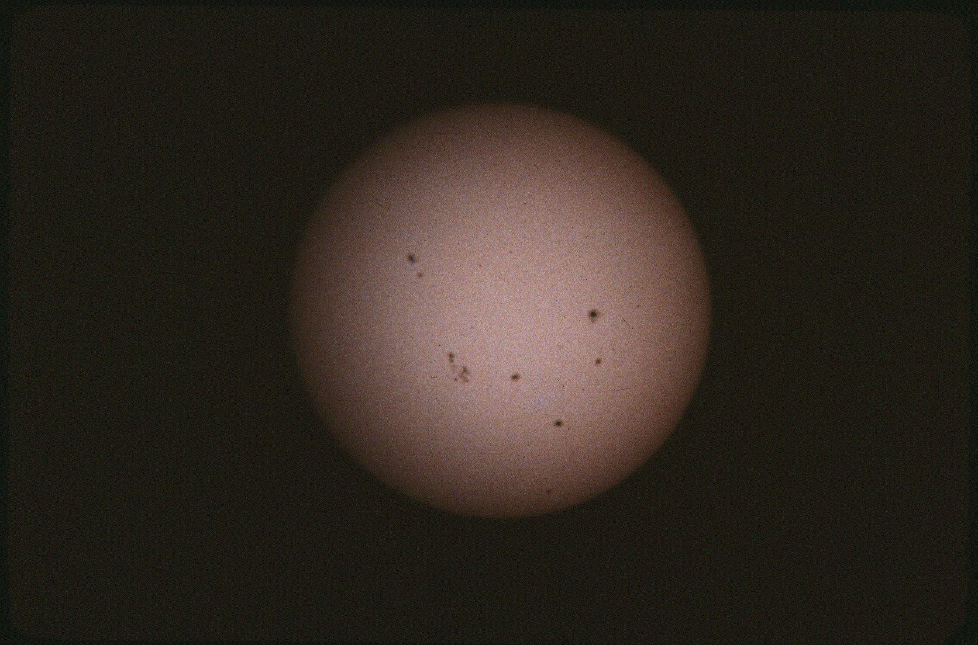
Figure #7: Full solar disk with groups of sunspots, showing
limb darkening near the edges of the solar disk.

We’ve already examined the granulation effect in the photosphere that transfers heat from the convection zone to the visible surface (photosphere) of the Sun. Well, the twisted magnetic fields produced within the convection zone through the effect of differential rotation are also the mechanism for producing another phenomenon in the photosphere, sunspots.

When sunspots are present an observer can also note that spots at different solar latitudes move at different rates — another consequence of differential rotation. At the equator it takes the Sun about 25.6 days to complete one rotation. At 60° north or south solar latitude, the Sun completes one rotation in about 31 days. And at the poles, it takes 36 days to make one rotation.

Cyclic Activity of the Sun

While the Sun may display some long term variability, solar activity has remained fairly constant since man first began to observe our life giving star. In 28 B.C. Chinese astronomers reported seeing naked-eye sunspots, though they did not realize what they were observing was physically on the Sun. They believed they were seeing something large pass between them and the solar disk. Other very large solar spots were sometimes witnessed through the ensuing centuries when clouds, dust, or horizon haze filtered out the Sun’s brightness. However, with the advent of the telescope in 1608 and its eventual application to observing the heavens beginning around 1609, the true nature of the sunspots was finally revealed.

Though Galileo Galilei (1564-1642) is often credited with the first observation of sunspots through a telescope, recent research has indicated it was Thomas Harriot (c 1560-1621) who first made a telescopic observation of sunspots in December 1610. Galileo is known to have shown sunspots to some of his friends while he was in Rome in May 1611, but no notes or papers were produced prior to then.

However, in a letter to Maffeo Barberini (an influential man from Florence and a friend of Galileo who eventually became Pope Urban VIII), dated June 2, 1612, Galileo writes, “For about eighteen months, I have been watching with the telescope some fairly dark spots in the body of the Sun, when it was near its setting ….” If this declaration is true, that would put Galileo’s first sunspot observation back around January 1611. This seems a little odd since Galileo had made his first Jupiter observations on January 10, 1610, and of the Moon a couple of months earlier.

Why wouldn’t he have focused his telescope on the most prominent body in the heavens? We may never know who was really first, but we do know that Galileo began a study of sunspots in April 1612. Figure #8 shows one of Galileo’s sunspot drawings:

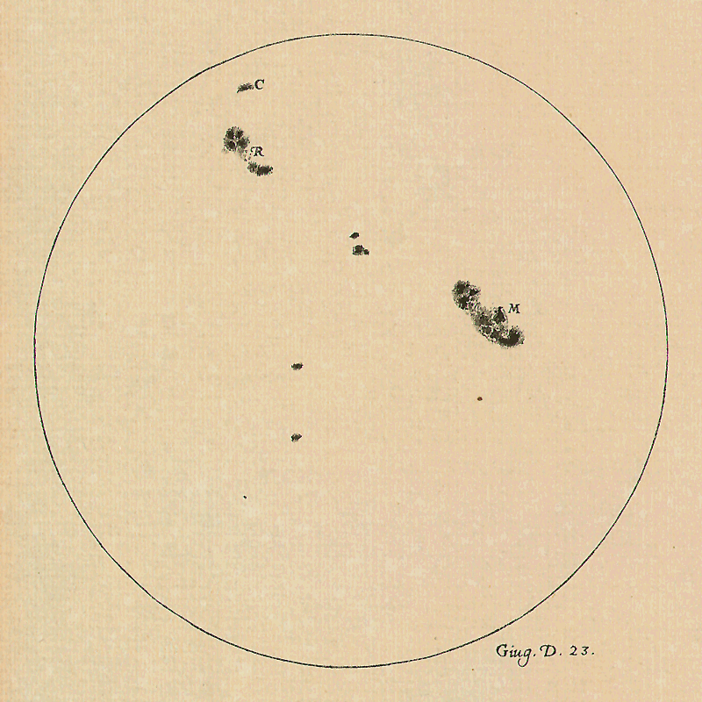
Figure #8
Researchers have selected and scanned thirty-six of Galileo’s drawings, from June 2, 1613 thru July 8, 1613 and animated the result. Please view both the slow- and fast-frame rate animations below. Note the evolution of spots and groups as they change over time. The position of the Sun’s equator becomes quite evident, as does the rotation rate of the groups in specific solar latitudes. Galileo was a keen observer and a good sketcher of what he observed. You will need to cut and paste these two URL’s into your web browser.

http://galileo.rice.edu/sci/observations/ssm_slow.mov

http://galileo.rice.edu/sci/observations/ssm_fast.mov

Sunspots

Since Galileo’s time we have learned much about the Sun and its activity. We now know that sunspots are created by very intense magnetic fields which break through to the photosphere

from the convection zone. These magnetic fields look like loops. Many twisted magnetic loops are created as a result of the very turbulent convection zone. When the loop reaches the surface, one end has a north magnetic polarity and the other has a south magnetic polarity. The very intense magnetic fields effectively cordon off the area and prevent new hot material from the top of the convection zone from entering into the “spot” region of the photosphere. As a result, the region loses energy and cools, causing it to appear dark. It’s only a contrast effect. If you were to remove a spot from the Sun it would appear extremely bright.

Spots usually start out as small dark pores only about 1,500 miles across. Most amateur solar telescopes cannot resolve pores this small. Depending upon the strength of the magnetic field, the spot may evolve into a more complex group of spots or disintegrate altogether.

The region where a sunspot forms is a depression or saucer shaped area in the photosphere, with a base is about 932 miles below the surface. See figure #9.

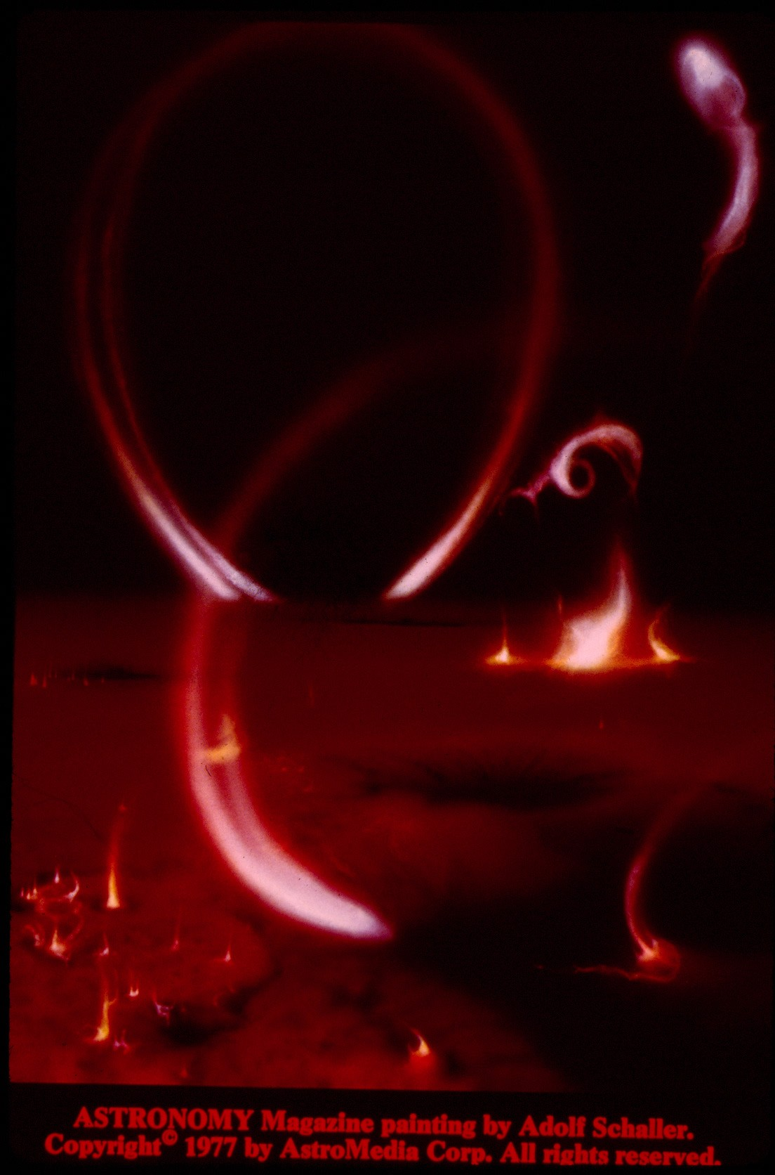
Figure #9
Graphic of photosphere/chromosphere showing a sunspot
as a depression.
Also shows flares and prominences.

Structurally a sunspot has a dark center, called the umbra, surrounded by a lighter region called the penumbra. See figure #10. The umbra has the most intense magnetism, while as one moves away from the umbra and into the penumbra the magnetic field lines become weaker. At the outer edge of the penumbra the magnetic field strength diminishes until it stops where the penumbra meets the 10,000°F material surrounding it. Likewise, as the magnetic field decreases as one moves outward from the umbra, the temperature of the sunspot increases as the magnetic field is not strong enough to prevent new hot material from welling up into the region.

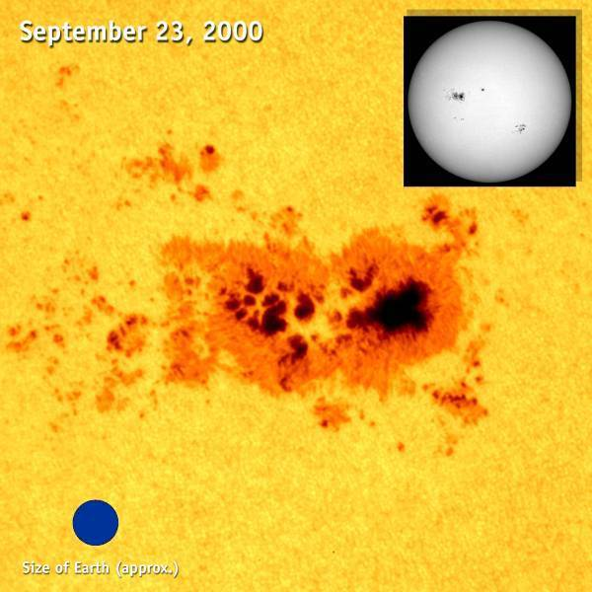
Figure #10
Sunspot group and Earth (7926 miles
in diameter) for comparison.

In contrast to the 10,000°F photosphere, the dark umbra of a spot is about 6,700°F. The penumbra varies in temperature from its boundary with the umbra out to the unaffected region surrounding it, so its temperature increases from 6,700°F to the 10,000°F. The magnetic fields can become quite complex, and a spot group can develop many tens of spots.

Sunspots do have a cyclic nature to them, though astronomers and those who model the Sun still do not have all the answers for its cyclic nature.

A solar cycle begins at solar minimum. While at minimum activity the Sun can be spotless for days, weeks and even months. An isolated spot may pop up here or there, but for all intents and purposes the Sun is considered to be in a quiescent phase, known as the quiet Sun.

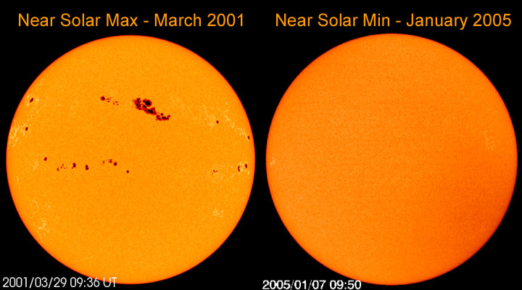
Figure #11 Self explanatory.

When a new spot/group forms during the beginning of a new cycle it develops in the Sun’s higher latitudes – around 30° either north or south.

As the cycle progresses, the number of spots and groups increase, as do their size and complexity. Spot and group formation also migrate toward the solar equator. By looking at a solar image an informed observer can easily determine the phase of the cycle. Individual umbra can be several times the breadth of the Earth. See figure #10. Over a period of years the solar activity increases until it reaches a high point known as solar maximum or also the active Sun. The rise from solar minimum to solar maximum varies with each cycle. The rise to peak is usually quicker, and the decline to minimum slower. The entire solar cycle, from minimum to minimum has been as short as nine years and as long as 14 years. Consequently, astronomers use an 11 year average to define the solar cycle. All one had to do is simply record their observations and notice the cyclic nature. The decades-long chart shown in Figure #12 (updated to only about 2003) clearly illustrates the 11 year cycle, but note that not all cycles are created equal.
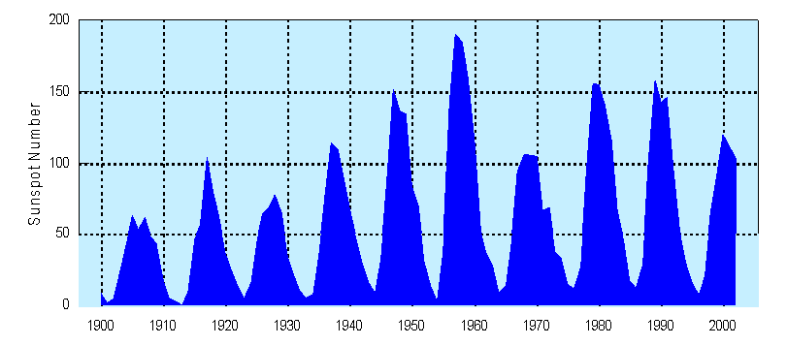
Figure #12

In 1848, astronomer Rudolf Wolf devised a formula so solar observers could uniformly report sunspot numbers. The formula is R = K(10g + f), where the relative sunspot number ( R ) equals 10 times the number of groups (g) plus the number of individual spots (f). The letter K is a correction factor for each observer to a set standard. Why? Because each observer uses a variety of different design telescopes and sizes, and each observer’s eyes and local observing conditions are different. For example, if you observed the Sun today and counted 3 groups and a total of 25 individual spots, your relative sunspot number R would equal 55 (3 times 10) + 25. The K correction would be developed by the receiving organization who is compiling the results from multiple observers.

In addition, for a given cycle we must look to the magnetic polarity of the spot group as the loop breaks through to the photosphere. (This observation cannot be accomplished visually. A spectrohelioscope captures an image known as a magnetogram which shows the location and strength of magnetic fields on the Sun.) To graphically show a spot group’s magnetic north or south polarity, each polarity is assigned a different color. Any color. Figure #13 used white for north polarity and black for south polarity. It could have been red and green.

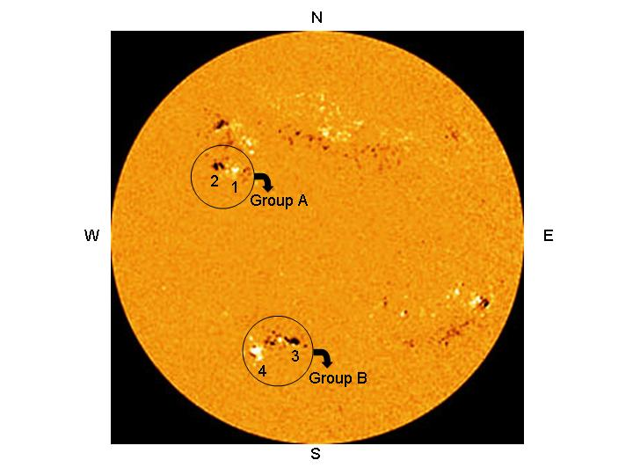
Figure #13 Magnetogram
Direction of rotation is West to East. White represents
north polarity; black represents south polarity.

Let’s closely examine the magnetogram in Figure #13. In the northern hemisphere group A, the leading spot 1 has a north polarity and therefore is coded white. Consequently the trailing spot 2 has a south polarity and therefore is coded black. Now look at the southern hemisphere group B. The leading spot 3 has a south polarity and therefore is coded black, while the trailing spot 4 has a north polarity and is coded white.

However, when the current solar cycle dies and the next one begins, the hemispheric polarities reverse! So, if the above image was taken 11 years later, the northern hemisphere’s group A leading spot 1 would be south/black and the tailing spot 2 would be north/white. And the southern hemisphere group B leading spot 3 would be north/white and the trailing spot 4 would be south/dark.

So while the sunspot cycle takes an average of 11 years to complete, there is a 22 year magnetic polarity cycle superimposed upon that. It is important to note that near the end of one cycle and the beginning of the next, spots of both polarities may and do coincide.

Astronomers have been tracking and numbering the 11 year solar cycle since 1755 with a sequential number starting at 1. Cycle 23 started in 1996, peaked in 2001, and was predicted to end in 2007. It didn’t! A new cycle begins with the appearance of a reversed polarity spot. That event didn’t happen until January 4, 2008, signaling the beginning of Cycle 24. Still, spots of both polarities can coexist for a time, and it wasn’t until December 2008 that cycle 23 ended. However, Cycle 24 didn’t “ramp up” as expected. In 2008 there were 266 out of 366 days that the Sun was spotless. This trend continued into 2009 as well. Only as Sun progressed deeper into Cycle 24 did solar activity increase. That included the more frequent appearance of sunspots and all the other activity associated with the intense magnetic fields generated beneath the solar surface. See Solar Cycle 24 Update on Blackboard.

Faculae and Plages

Using white light filters, observers often see bright regions surrounding an area where a sunspot or group already exists or may form. These features, called faculae, are more easily detected when they are close to the edge of the sun’s disk due to the limb darkening effect mentioned earlier. Faculae are also the consequence of strong magnetic fields. A related phenomenon, called plages, occurs in the lower chromosphere (a region of the solar atmosphere examined shortly), so they are best seen with hydrogen alpha (H-alpha or Hα) filters. These filters isolate a specific spectral line of hydrogen at a wavelength of 6562.8 angstroms. Plages also appear as bright regions surrounding active regions, but they can be observed across the entire solar disk. The relationship between faculae and plages is unknown.

Figure #14 illustrates how filters designed to observe specific wavelengths of light can show different solar features. Simultaneous images of the active region reveal details about the complexities of solar phenomena.
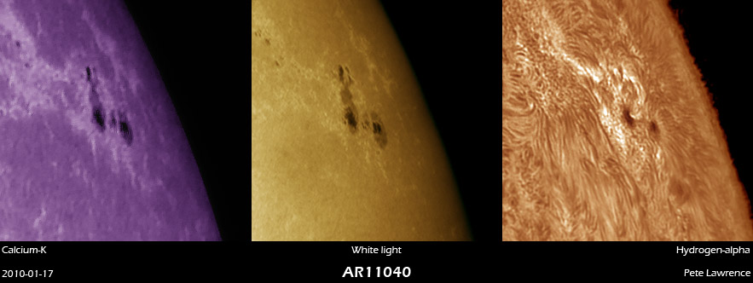 Figure #14

Occasionally some very bright flashes in white light would occur between spots or above spot groups. These proved to be very energetic explosions called solar flares. When H-alpha filters were developed, astronomers could watch these massive explosions in much greater detail. Flares eject large amounts of high-energy particles and gas thousands of miles from the Sun’s surface. They are also extremely hot, ranging from 3.6 million to 24 million°F. Flares occur above active solar regions in the chromosphere.

We already know that sunspot groups are areas of intense magnetic fields. Solar physicists also know that magnetic fields can store and hold a lot of energy. Though the physics are complex and still debatable, magnetic reconnection is theorized to be the process responsible for producing flares. Diverse magnetic field lines that were anchored to a sunspot region somehow get “pinched” off. They drift upward above an active region, and when they reconnect to each other or cross, all the stored energy is released in one colossal burst, usually lasting only a few minutes. The small scale analogy would be like crossing two live bare copper wires. Solar flares contribute to the heating of the corona and also briefly enrich the solar wind.

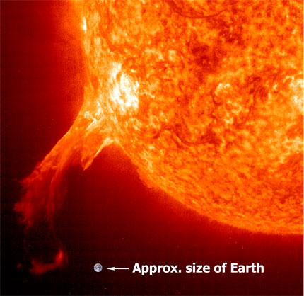
Figure #15 Solar flare and Earth comparison.

Here is a movie clip of several solar flares. Again, keep in mind that the clip is a time-lapse movie. Flares live for no more than a couple of tens of minutes and eject from the Sun very rapidly. Since the sun averages 93 million miles away, to see motion would require a few minutes of elapsed time. However after saying that, one can observe flares in real time.

http://www.youtube.com/watch?v=FkplsYfN2ag

http://www.youtube.com/watch?v=ys9xL3mw8tI

These very energetic protons and elections (plasma) spew into space. If the flare occurred above a sunspot group facing in the general direction of the Earth, in 1 1/2 days these particles may encounter the Earth. The particles get trapped by the Earth’s magnetic field, and the material is then directed towards the Earth’s poles. As the particles slide down the Earth’s magnetic field lines they excite atoms and molecules within our upper atmosphere. This interaction produces one of Mother Nature’s most beautiful light shows, the aurora borealis (northern lights), and its southern counterpart, the aurora australis (southern lights).

http://www.youtube.com/watch?v=HTPrwgP8oFY (Flare/CME Causing Aurora)

Please watch the following videos of the Aurora.
http://www.youtube.com/watch?v=9AoIBt-zgn0
http://www.youtube.com/watch?v=3sa-3DoXHQQ&feature=fvw
http://www.youtube.com/watch?v=FcfWsj9OnsI&feature=related
Particles from the solar wind are always entering our upper atmosphere near the poles, and aurora in both hemispheres are common even without enhanced solar activity. However, it takes a flare of great intensity for its affects to cause an aurora that can be visible from more equatorward latitudes like here in Rhode Island. These three images (Figures #16-18) were taken of the northern lights from Rhode Island and nearby Massachusetts.

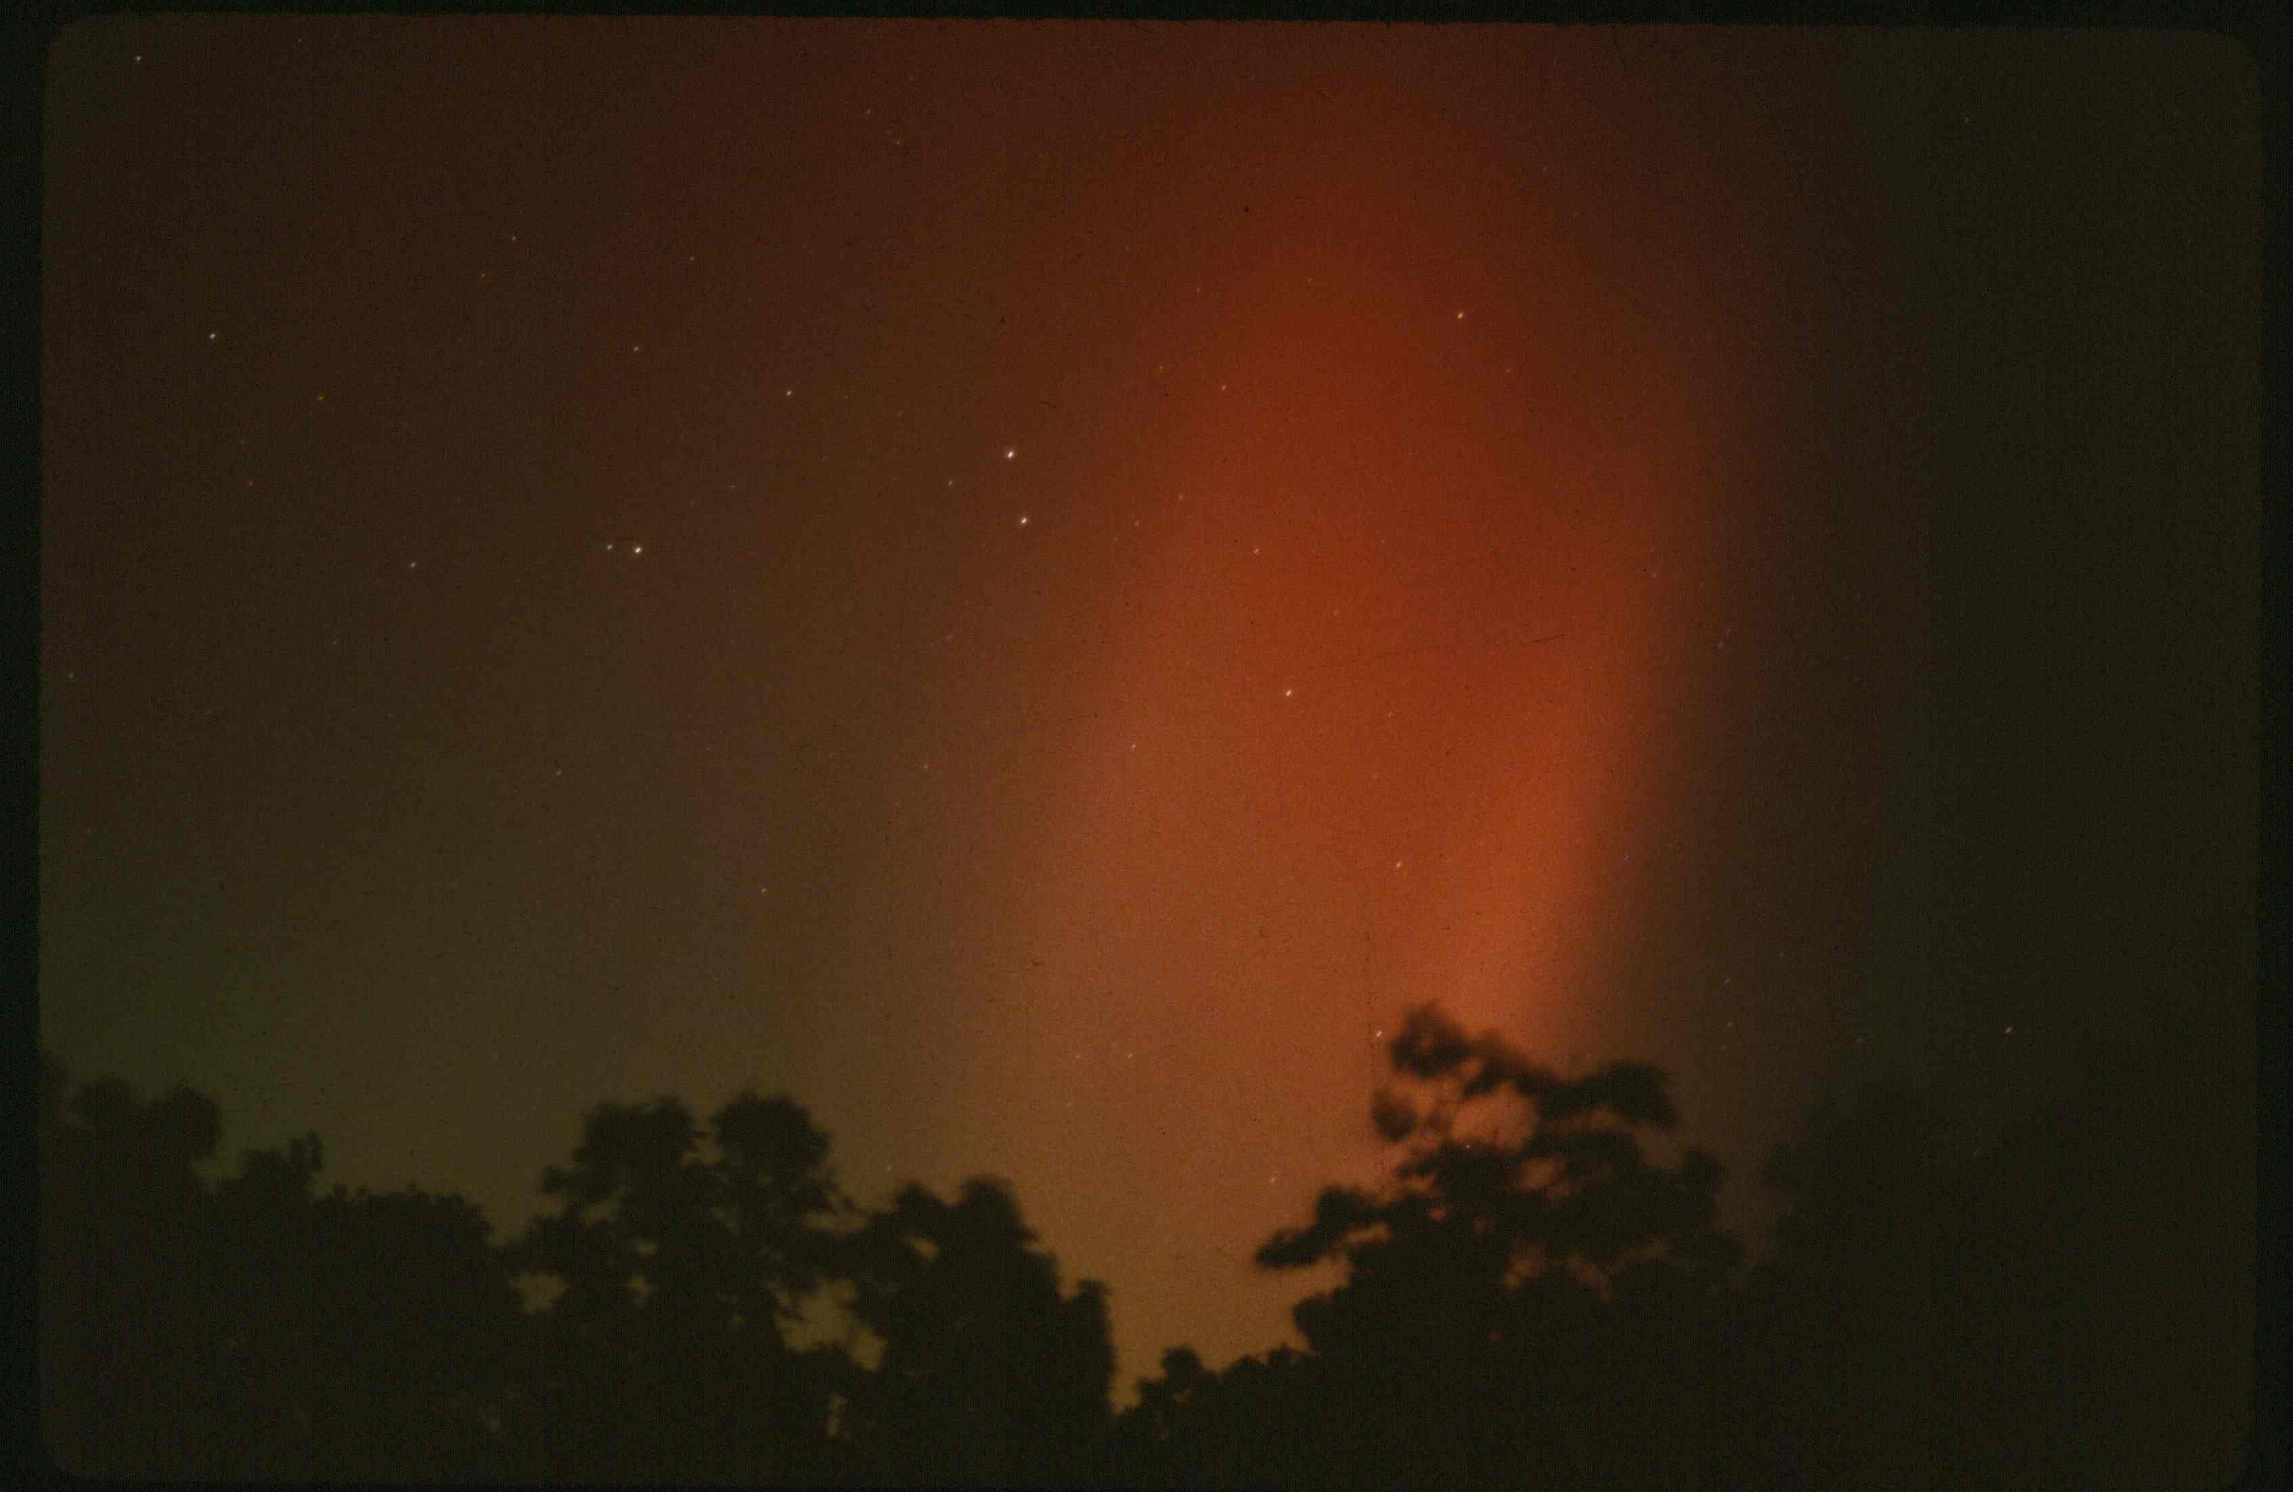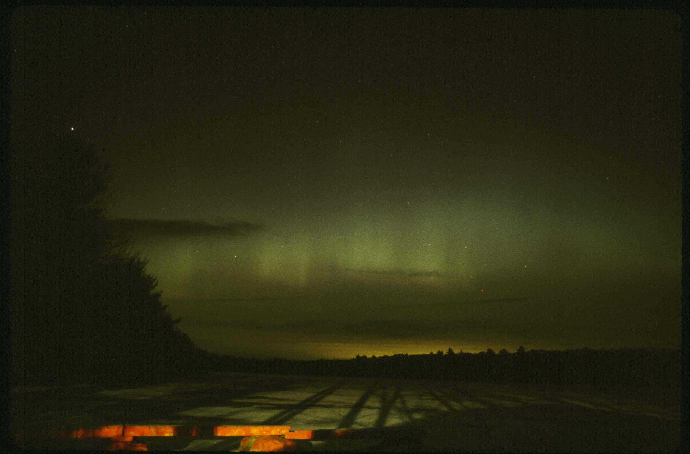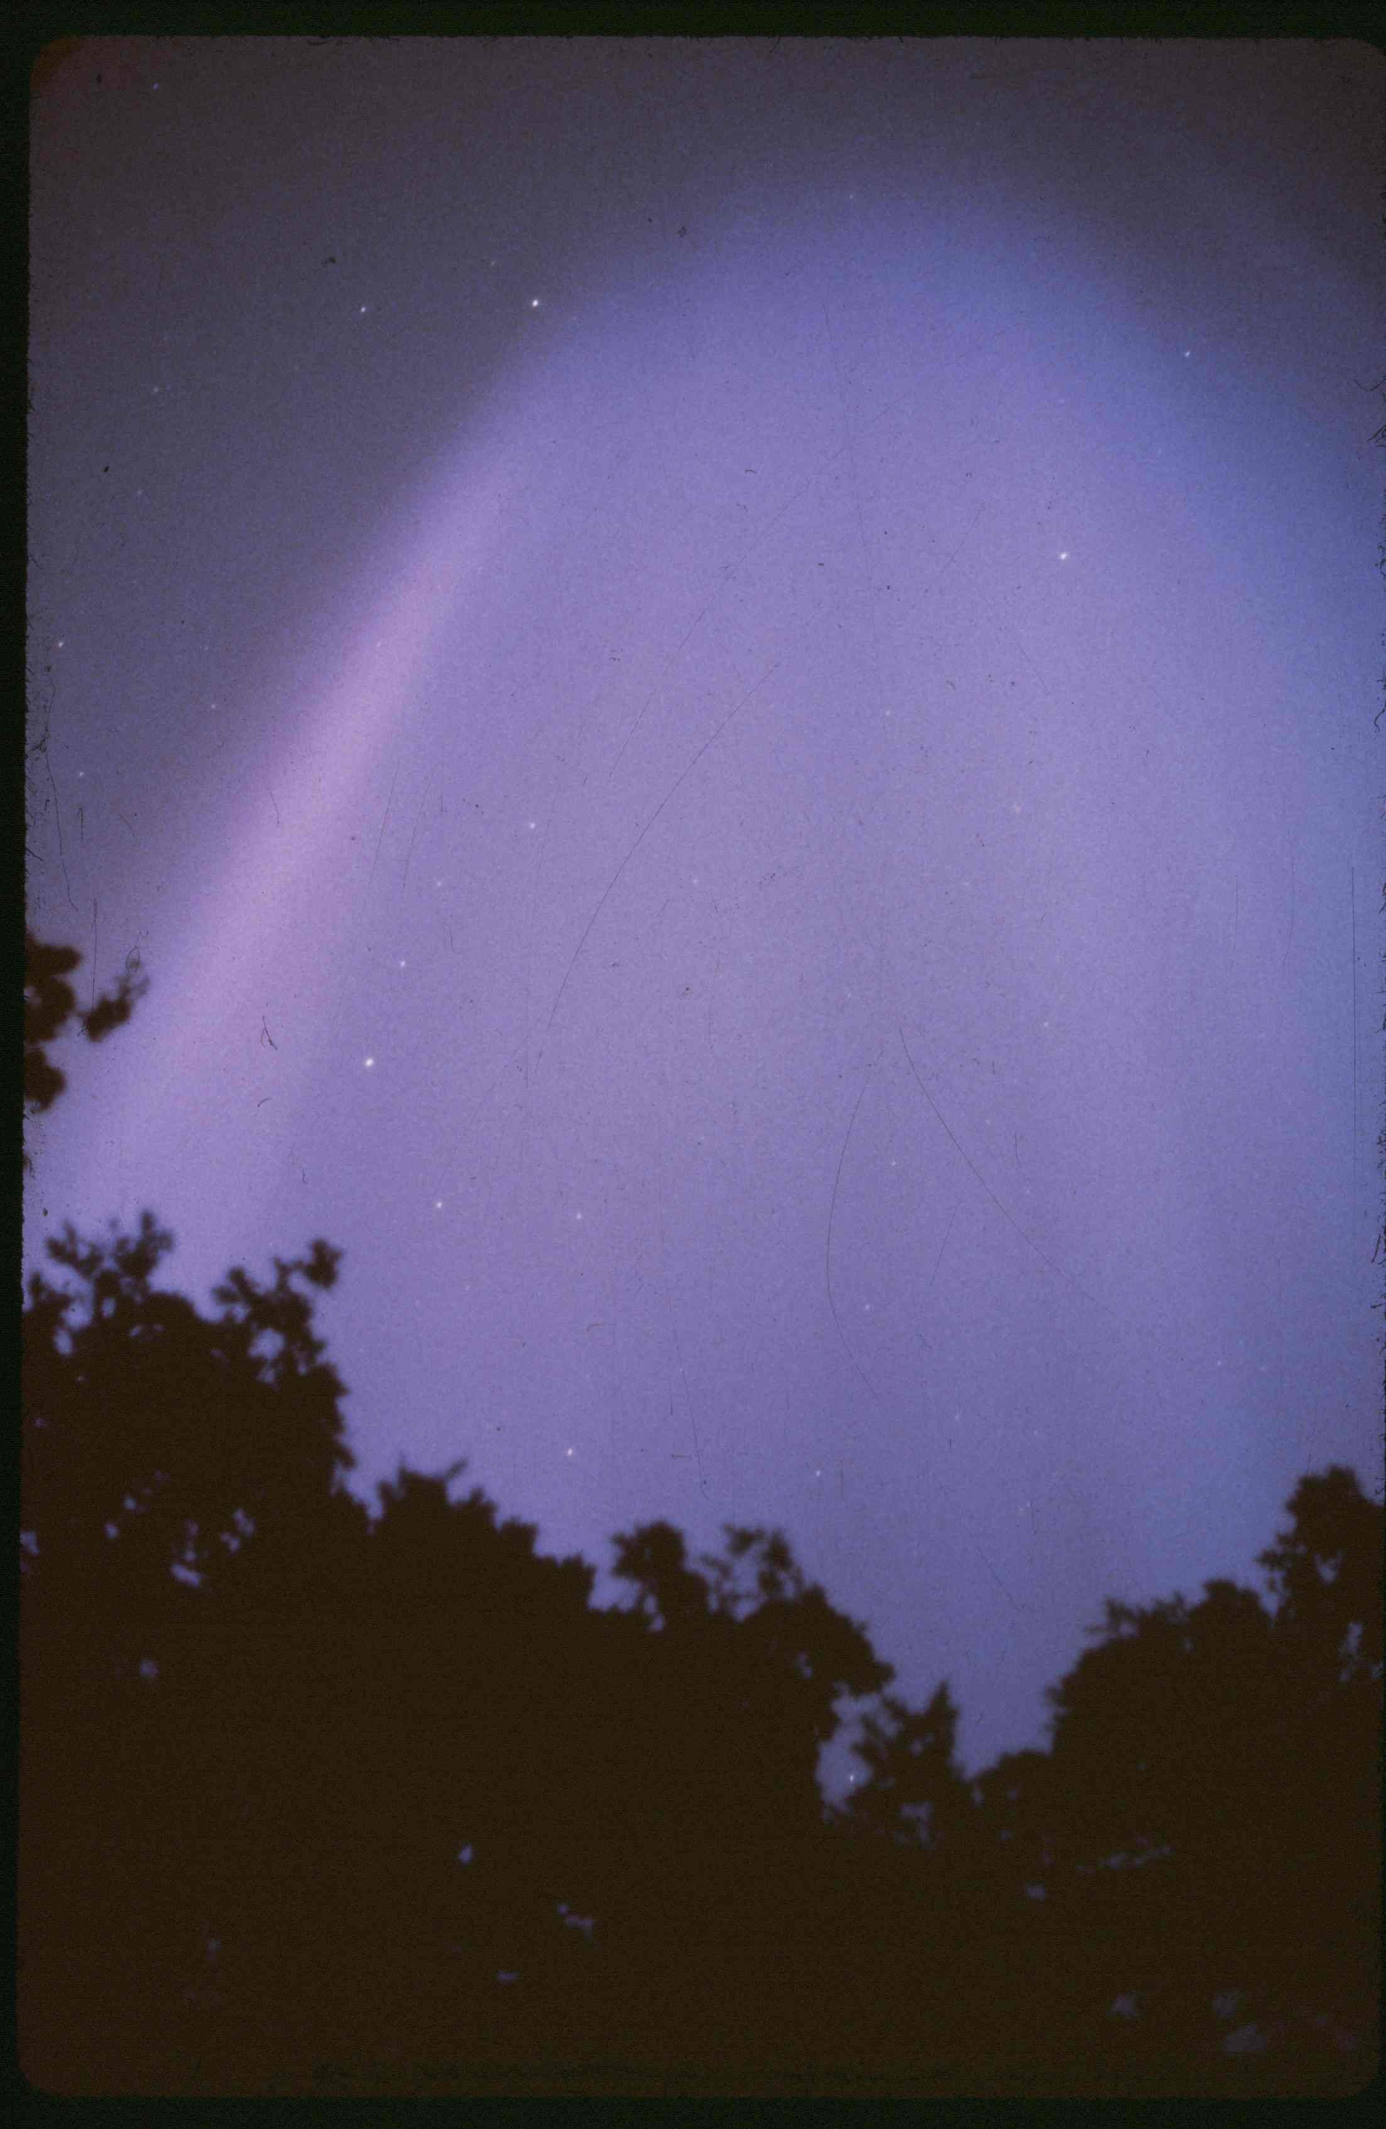
Figure #16 Figure #17 Figure #18

Solar flares can cause more detrimental effects than the aurora.

People flying at high altitudes will experience more radiation than normal, and astronauts are put at a greater health risk as well. These very energetic particles can cause major power grid blackouts and severely damage power transmission lines. The aurora also severely affects the Alaskan pipeline because electrical currents are induced into the long baseline pipe like a wire, causing the pipeline to corrode faster. They can also “fry” earth satellite electronics and interrupt communications systems. They can heat up the Earth’s outer layers of the atmosphere more than normal, which can cause the atmosphere to expand.

In 1979, the United States’ first space station called Skylab found itself in this very predicament. A high level of solar activity expanded the atmosphere, increasing the drag on the vehicle, which caused its orbit to decay much sooner than expected. While NASA had planned to use the not yet flown shuttle to boost Skylab’s orbit, delays in the shuttle program prevented that
rescue. Skylab entered the atmosphere and disintegrated on July 11, 1979. The irony of the whole scenario was that Skylab’s primary mission was solar research!

Mark my words – during the next solar maximum now predicted for 2013 – I predict cell phones will become sporadically useless during an approximate two-year period centered on that date, and folks so used to GPS for directions are going to have to relearn how to read a map!

The Solar Atmosphere: the Chromosphere

This region was well known to astronomers and the general public alike even before the telescope was invented. The chromosphere sits just above the photosphere and is about 1,243 miles thick. It can be seen as a red layer very close to the dark limb of the Moon which blocks the bright photosphere during a total solar eclipse. It is red because that is the emission spectrum of hydrogen gas in the visible spectrum. From the bottom to the top of this region temperatures vary from about 7000°F to 36,000°F. Notice the red chromosphere (prominences) in the following image (Figure #19) I took of the total solar eclipse of February 16, 1980, in Tanzania. The “diamond ring” effect is also captured, as well as the inner corona.

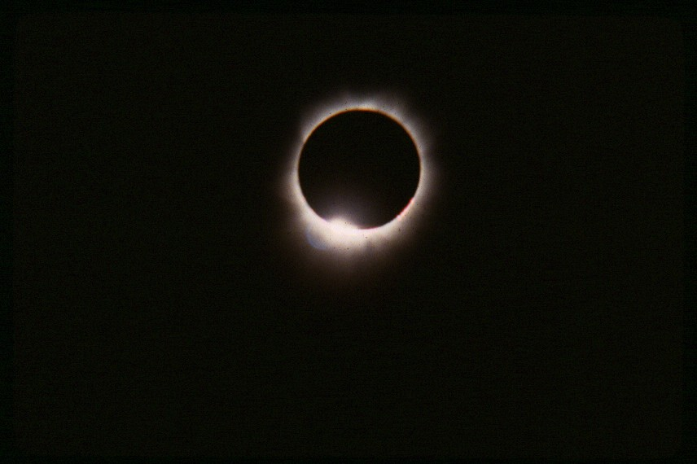
Figure #19

Another effect of increased solar activity is the appearance of prominences. Prominences usually align themselves to the magnetic field lines of a sunspot pair or group. These eruptions, which extend from the photosphere/chromosphere boundary, move upward several thousands of miles into the corona and are observable with H-alpha filters. Though they can manifest in a variety of forms, prominences usually look like huge arching loops of material extending beyond the limb of the Sun. Prominences can also appear like huge cloud-like features suspended above the solar limb. Over time an observer can watch as this cooler material rains back down onto the photosphere.

Figure #20 shows a loop prominence.
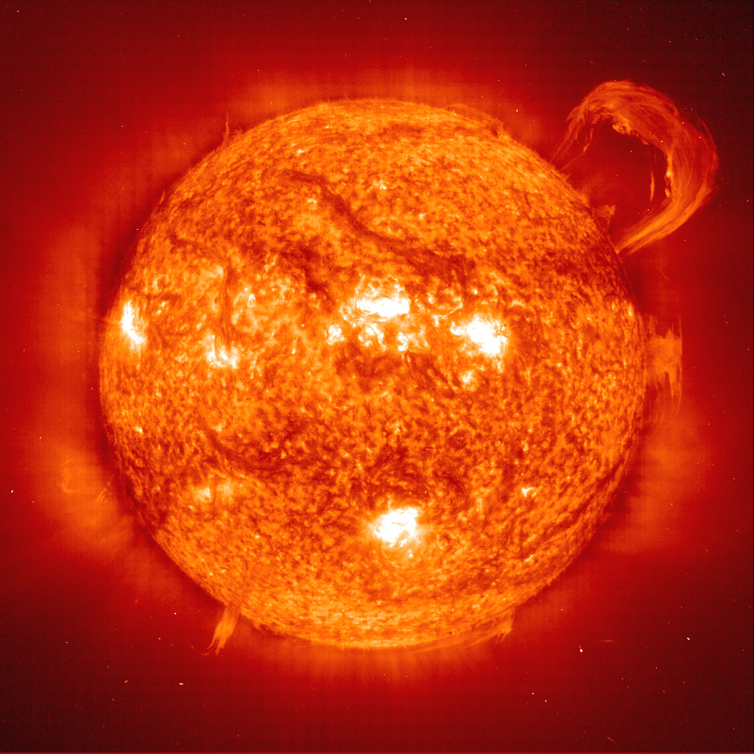 Figure #20

http://pocket.eb.com/new-multimedia/mp4/sun000003.mp4

http://vimeo.com/11125635

http://www.youtube.com/watch?v=zbPNcjj__iE&feature=related

When a prominence is observed away from the solar limb it is called a filament. Also observed in H-alpha, a filament will look like a dark line seen in silhouette against the solar disk. It contains cooler material suspended above an active region and seen in contrast to the brighter and hotter surface below it. Quiescent prominences can take days to form and can last for days. Eruptive prominences occur when the magnetic field of a filament collapses. We are now talking only hours for the prominence to arch away from the surface of the Sun.

High resolution images of the solar limb reveal a feature similar to prominences, except on a much small scale, about 500 miles in diameter. These features look like an old English hedgerow and are called spicules. http://www.youtube.com/watch?v=U1WsC1TR-x8

Sound waves propagate as shock waves from the photosphere (granulation effect) into the chromsopshere forming and shaping these columns of gas. While spicules are considered to be permanent features of the chromosphere, individual spicules have a lifetime of only about five minutes.

The Solar Atmosphere: the Corona

The solar corona is the outer atmosphere of the Sun, extending about two million miles into space. It too was known to eclipse observers long before the invention of the telescope. The pearly white cloud seen surrounding the Sun during total solar eclipses is remarkable. During each eclipse it exhibits a different shape and intensity. We later found out this was due to a cyclic variability in solar activity.

The lower altitude limit for the corona puts it almost down to the photosphere. In fact, it most likely overlaps the chromosphere, so its lower temperature limit is about 36,000°F. However, over its entire volume, the average coronal temperature is about 1,800,000 – 3,600,000°F, while the hottest regions are from 14,400,000 – 36,000,000°F. How can the corona be so hot when the Sun’s photosphere (surface) is a mere 10,000°F?

The heating of the corona is still somewhat of a mystery today. Some researchers believe it is caused by huge shock waves emanating from the solar surface as the granules bubble to the surface, while others believe a portion of the heat is due to magnetic reconnection. The solar corona is always spewing material into space and creates what is known as the solar wind. The solar wind extends about 50 AU (astronomical units) out into the far reaches of our solar system. One AU equals 92,955,087 miles (93,000,000 rounded), the mean distance of the Earth from the Sun.

The densest region of the solar corona extends 1-2 solar radii (432,000 – 865,000 miles) outward from the photosphere. Holes in the magnetic field of the Sun that hold the corona in place allow the particles to escape as the solar wind. Particles are always evaporating away from

the Sun, but the coronal holes facilitate this action. One does not need a total solar eclipse to see the Sun’s corona these days. A device called a coronograph uses an artificial disk to block the Sun’s brightness so the corona can be observed.

Figure #21 is another one of my images from the total solar eclipse of February 16, 1980, this time showing the outer corona, but still showing some of the chromosphere near the Moon’s edge.

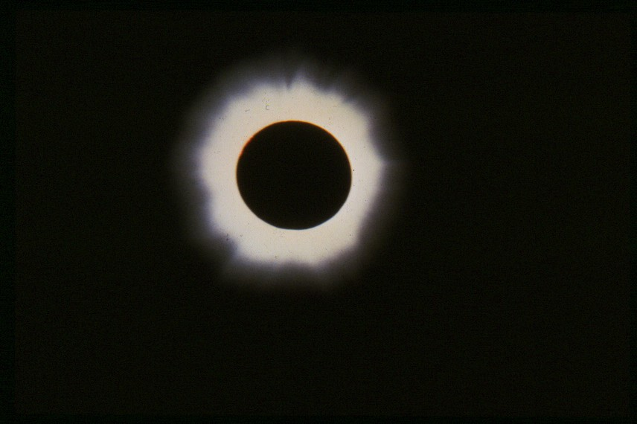
Figure #21

The most explosive events to happen “on” the Sun are CMEs, or Coronal Mass Ejections. While CMEs were once thought to occur with solar flares and eruptive prominences (detailed earlier), CMEs have occurred independently without their presence. CMEs have also been observed above non-active regions. It appears that CMEs do originate in the Sun’s corona (hence the name), and that a similar magnetic reconnection process (like that which causes flares) is at work. Huge amounts of energy become trapped within a magnetic field. For a time it is sufficiently contained. Then the force is too great and the magnetic field line is broken, releasing all the energy towards space.

CMEs can occur at anytime during the solar cycle, but like the other visible effects that increase as the solar cycle progresses from minimum to maximum, CMEs also follow this cyclic enhancement. While CME’s are not an everyday occurrence, their infrequency suggests that conditions in the corona seldom produce situations where the amount of stored energy does not often exceed the magnetic field strength to contain it.

The latest research indicates that the mechanism for producing CMEs is still subject to additional observation and interpretation. However, it is thought CMEs may be triggered by filaments/prominences “exploding” up into the corona. Movies of CMEs provide a wealth of information. A halo CME shows the CME lifting away from the Sun in a halo-like form, much like a balloon popping in slow motion. Here is a movie showing a coronal mass ejection:

http://www.youtube.com/watch?v=RQxfN45UTF0&feature=related

These halo CMEs are often Earth directed and can affect our planet dramatically. The material, extremely hot and very energetic electrons and protons, streak out into space along the Sun’s magnetic field lines, reaching temperatures of up to tens of millions of degrees. While the solar wind usually takes four to five days to reach us, a large flare or CME can reach the Earth in one

and a half to two days. A CME can expand into space at about one million miles per hour, and can spew one to ten billion tons of plasma (high energy protons and electrons) into space.

CMEs also produce the same effects on the Earth as flares. However, CMEs can be even more damaging. CMEs are more often than not the mechanism for producing aurora at lower Earthly latitudes.

Some Odds and Ends: Neutrinos
Have you heard about neutrinos before? Neutrinos are created as part of the nuclear fusion process deep within the Sun’s core. While it might take a photon thousands of years to travel to the surface of the Sun and escape as light, a neutrino, which has only a very slight mass, does not react with any of the Sun’s material and flies through the star as if it didn’t exist.
Solar models predicted neutrino creation in certain quantities, but early experiments to detect them came up short. Very short. Only a third of the predicted neutrinos were detected. Astronomers had no theory to account for this discrepancy. How could their models be so incorrect? Were the detectors not sufficiently sensitive?
Well, the models were correct. It seems that once an electron neutrino was created, the neutrino could oscillate. This oscillation could change the electron neutrino to a tau neutrino or a nuon neutrino. Once this oscillation effect was known, new detectors were built and in 2001 all three neutrino “flavors” were finally detected. And yes, the numbers then matched what the solar models had predicted.
Possible Long-Term Effects of Solar Activity
It has already been noted what affect enhanced solar activity has on the Earth and its atmosphere. Theories abound that speculate whether chemical changes and huge electromagnetic currents in our upper atmosphere have an adverse effect on the Earth’s delicate biosphere, particularly our climate.
It is thought that the severe winter of 1977-1978 was due to an inactive Sun. Is there any precedent for making this assertion? Yes, there is.
Following the pioneer work of Galileo and Harriot among others, solar research soon became a well established discipline of study. However, something very strange happened around 1645. Despite the short time frame from their observations, the cyclic nature of sunspots was well established. Then practically overnight sunspots ceased to exist. Since solar observers had only seen several 11 year cycles, they had no idea if the lack of sunspot formation was part of an additional cycle. While an occasional spot popped into existence, the mechanism responsible for creating the spots seemed to shut down.
It is well documented that within the Maunder Minimum there was a 30 year period where solar observers recorded only about 50 sunspots total! A more “normal” period would have produced an estimated 40 to 50 thousand spots!
It is also a well fact that the Maunder Minimum coincided with the middle and coldest part of the Little Ice Age in Europe and North America. Was the lack of sunspots the primary cause of this cool down? Some researchers believe it may have been a combination of effects including decreased solar activity, such as: increased volcanic activity, a real variability in global climate, and the shut down of the transatlantic conveyor belt current which brings warm water from the Gulf of Mexico to the North Atlantic. Perhaps another unknown mechanism was responsible for

this solar variability. Whatever the reason, it drastically affected the population of Europe. Starvation was widespread, and in 1709 the Rhine river remained frozen until summer.
It wasn’t until 1715 that the Sun returned to its normal cycle. That 70-year period has become known as the Maunder Minimum. When the spots returned after such a long absence, several scientific papers were written because the phenomena weren’t observed for so long and were once again considered unique.
Observing and understanding our life-giving star and its effects upon the Earth is important to each and every one of us. We take our Sun for granted, but as you can see, minor changes in the energy output of this five billion year-old star can happen practically overnight and create serious consequences worldwide.

Looking at the stars always makes
me dream, as simply as I dream over
the black dots, representing towns
and villages on a map. Why, I ask
myself, shouldn’t the shining dots
of the sky be as accessible as the
black dots on the map of France?
—Vincent Van Gogh

While there are many estimates for how long it takes the energy created in the Sun’s core to reach the photosphere, surprisingly we are talking about tens of thousands to a couple of hundred thousand years.

